*Practical 2:Exploring basic commands in Unix/Linux :*

**Outputs :**

1. Simple Filters (head and tail) :

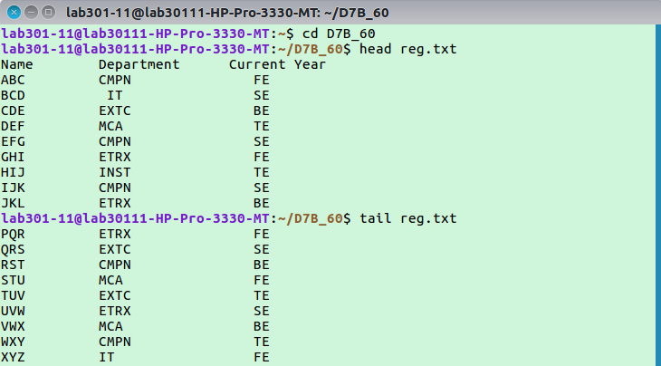

2. Pattern Matching (grep and sort) :

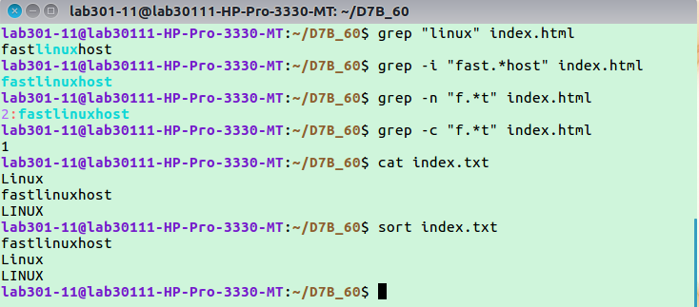

3. Advanced Pattern Matching (awk) :

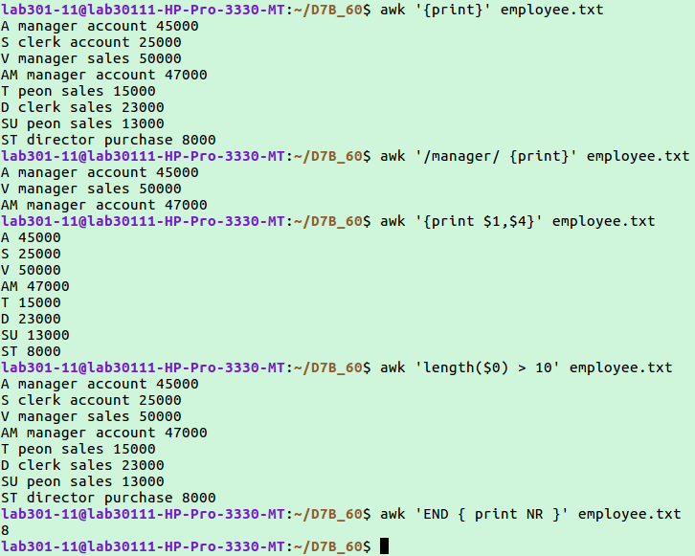

4. Report Formatting (nroff and troff) :

a) nroff :

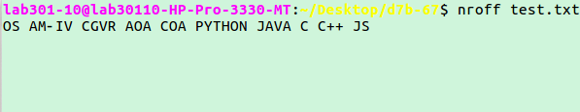

b) troff :

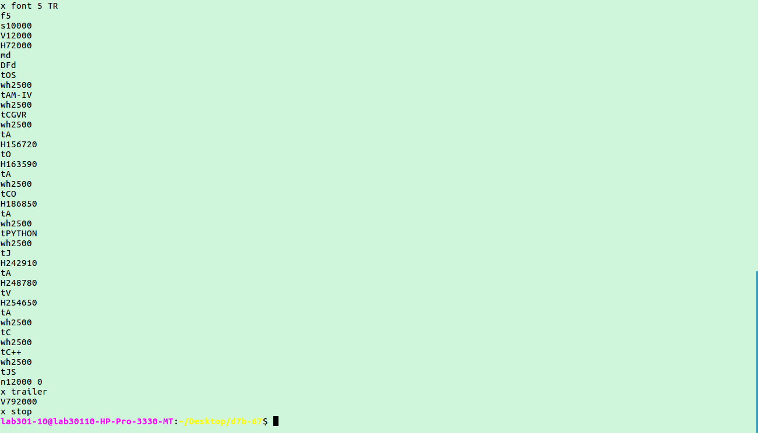

5. Creating and managing groups (sudo su, adduser, su, deluser, groupadd, usermod, passwd)

